
Project Report
Part 1: Source Encoder and Decoder

October 20, 2025
EECE 442
Ziad Abillama & Joseph Chahine

Introduction
This project explores the stages of a digital communication system, from signal representation and sampling to quantization, source coding, and reconstruction. This report presents the first part of our project, which focuses on building the foundation of a digital communication system. The report will be divided into three parts. It begins with the study signal representation through sampling, where signals are sampled and reconstructed to verify the Nyquist-Shannon theorem. This part also covers sampling through Fourier series, analyzing how signals can be represented in the frequency domain. Following that, the report explores quantization, examining how continuous amplitudes are mapped to discrete levels and how this affects distortion. Finally, source coding and decoding techniques are implemented to efficiently compress and reconstruct the quantized data.

Section 1 – Signal Representation through Sampling
This section focuses on understanding how continuous-time signals can be represented and reconstructed in discrete form. It explores two complementary approaches: time-domain sampling and frequency-domain (Fourier) representation. In the first part, a cosine signal is sampled above and below the Nyquist rate to verify the sampling theorem and demonstrate the effects of aliasing. In the second part, the same signal is represented through a finite Fourier series (FFS) to analyze the effect of the number of harmonics on the reconstruction accuracy.

1.1 – Generic Sampling
In this section, the goal is to verify the Nyquist-Shannon sampling theorem by sampling a continuous-time cosine signal x(t) = cos(2πf₀t) at two different rates: one above and one below the Nyquist frequency f_{N} = 2f₀.

Sampling Results
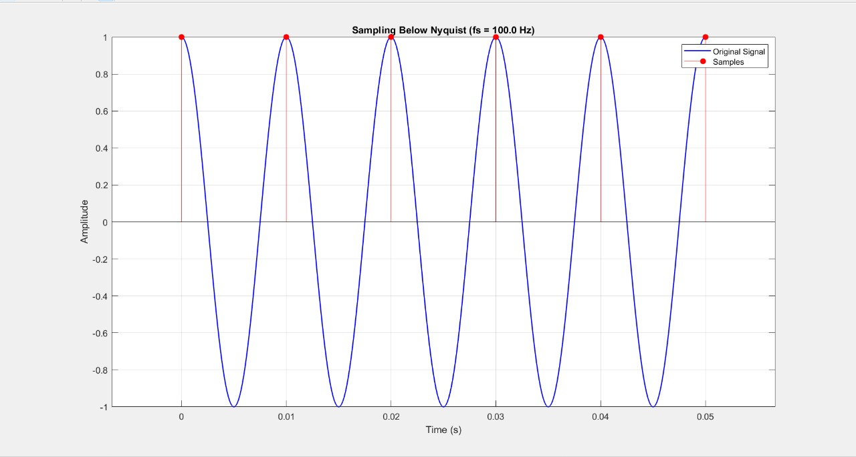

Figure 1. Sampling below the Nyquist rate (f_{s} = 100Hz)

Result: Important waveform details are missing, leading to potential aliasing.

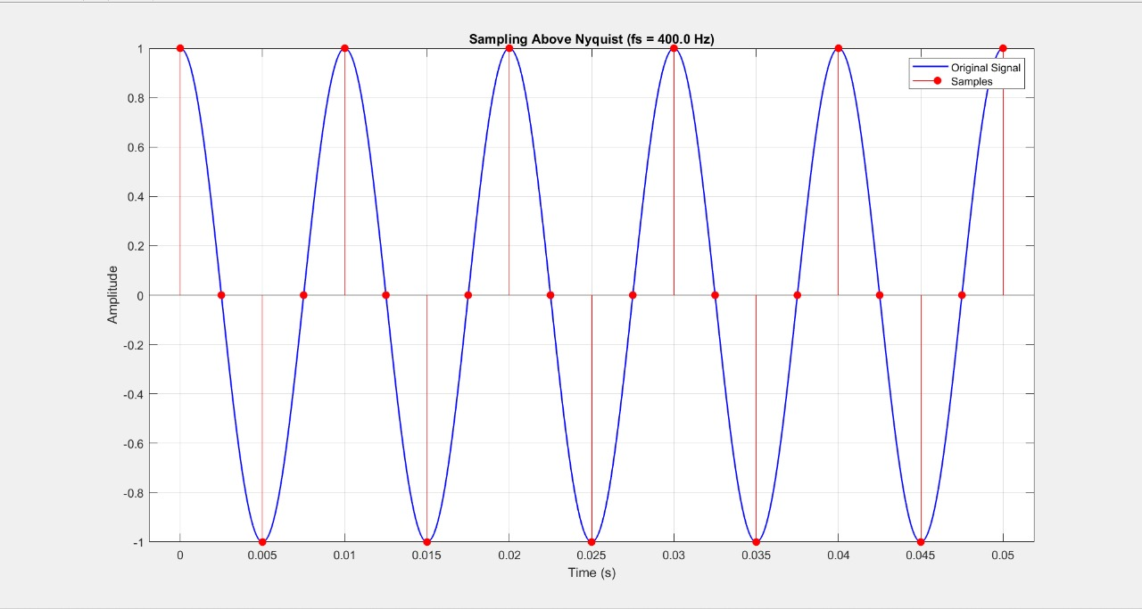

Figure 2. Sampling above the Nyquist rate (f_{s} = 400Hz)

Result: Sample points capture every feature of the signal.

Reconstruction Results

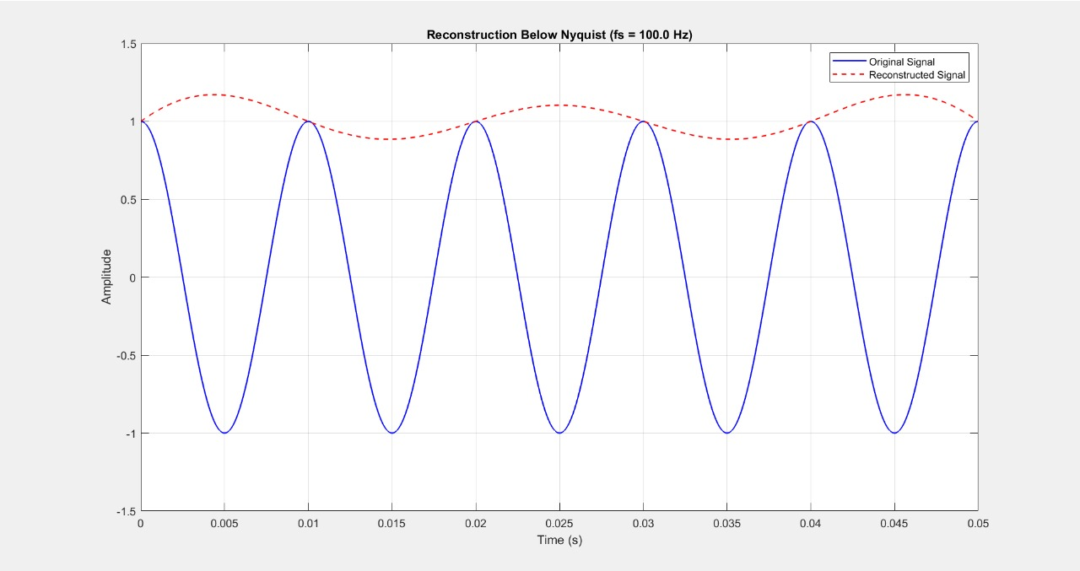

Figure 3. Reconstruction below the Nyquist rate (f_{s} = 100Hz)

Result: The reconstructed signal deviates heavily from the true cosine, exhibiting a lower apparent frequency and distorted shape.

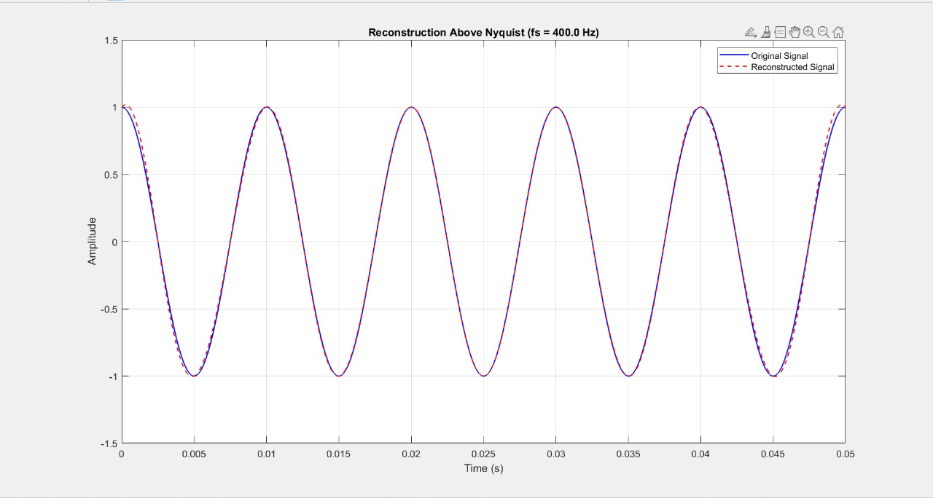

Figure 4. Reconstruction above the Nyquist rate (f_{s} = 400Hz)
Result: The reconstructed signal almost perfectly overlaps the original waveform. Both amplitude and phase align in both signals.

Quantitative Comparison
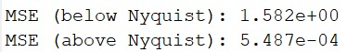

Figure 5. Mean Squared Error (MSE) comparison between sampling rates

Result: The MSE values quantitatively confirm the visual results. The error for above-Nyquist sampling is nearly zero, while the below-Nyquist case yields high reconstruction error due to information loss and aliasing.

Discussion
The reconstruction with f_{s} $≥$2f_{max} more closely matches the original signal. At this sampling rate, all frequency components are captured, resulting in accurate waveform recovery. When f_{s} < 2f_{max}, aliasing occurs, causing overlapping of frequency components and distortion in shape. These results confirm the Nyquist–Shannon sampling theorem: proper sampling enables faithful reconstruction, while undersampling leads to significant errors.

1.2 – Sampling through Fourier Series
In this section, the goal is to represent a time-limited signal using a finite Fourier series (FFS) and analyze how well the approximation reconstructs the original signal.
Two analyses are conducted:
- Varying the number of harmonics (n) while keeping the period constant.
- Varying the period (T) while keeping n high

Varying n with fixed T
(Keeping T = 2s constant and increasing n from 0 to 80)
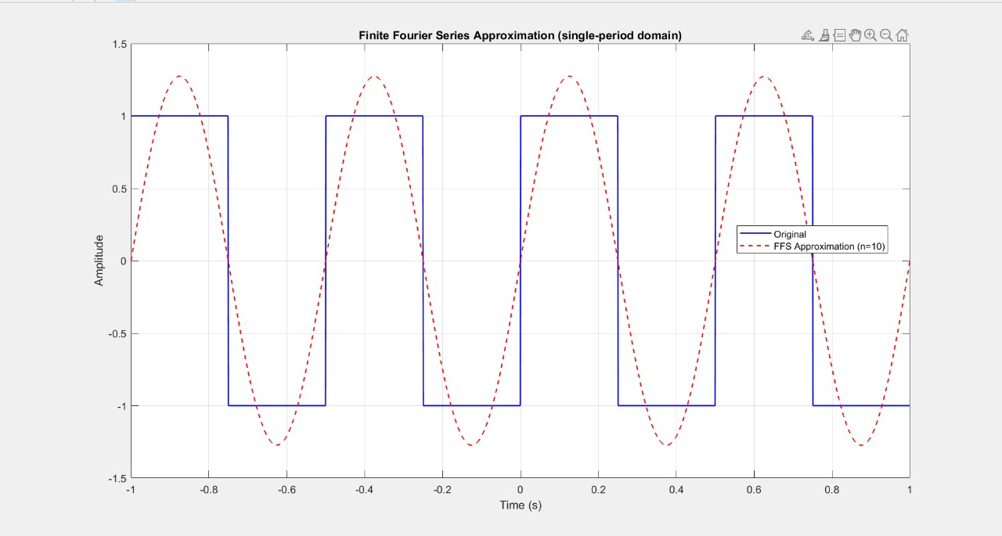

Figure 1. FFS approximation with n = 10
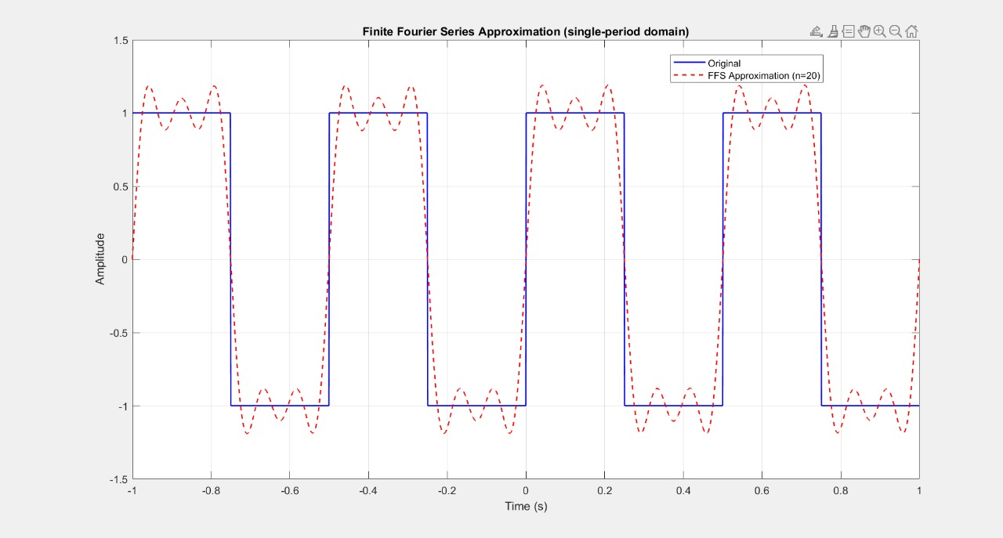

Figure 2. FFS approximation with n = 20
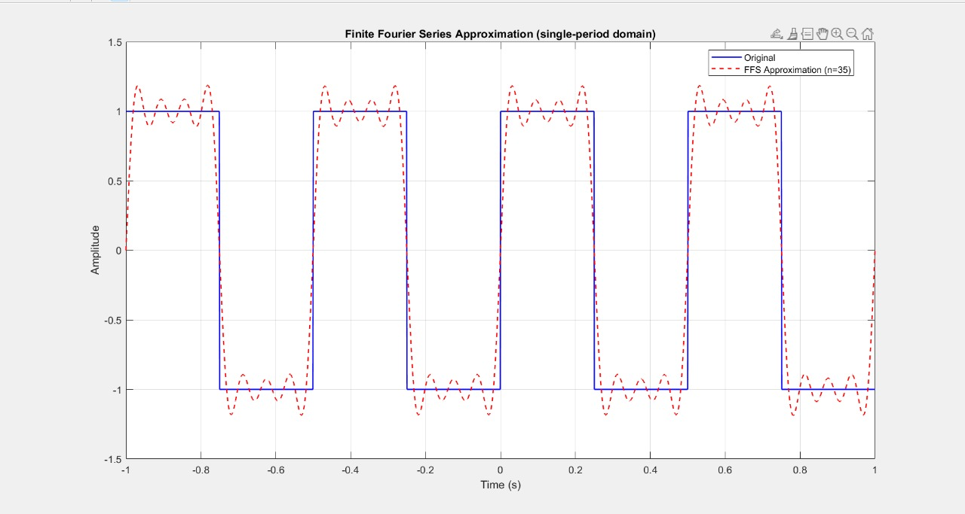

Figure 3. FFS approximation with n = 35

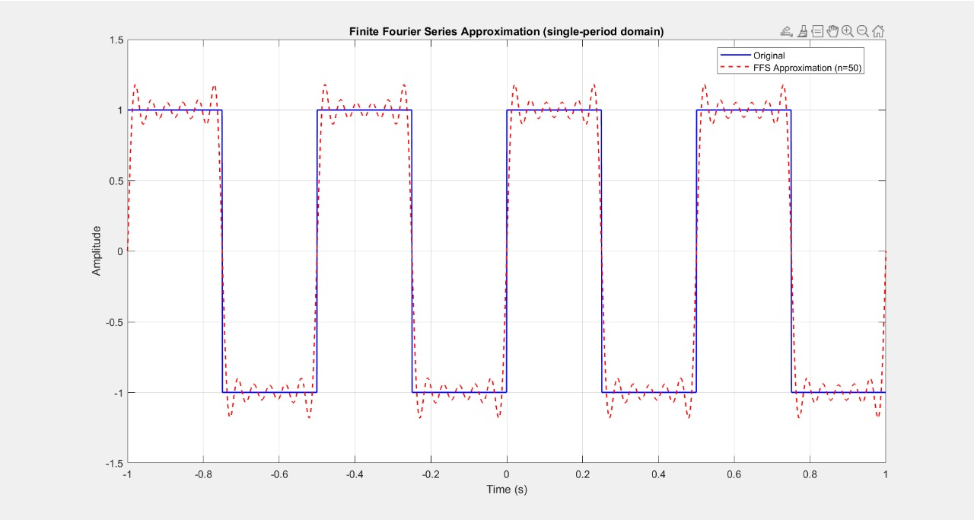

Figure 4. FFS approximation with n = 50

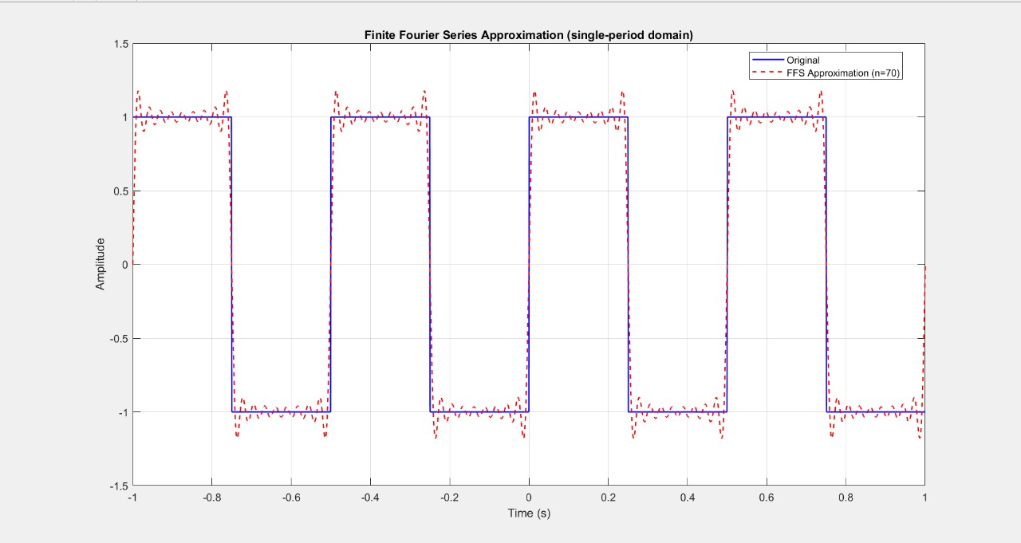

Figure 5. FFS approximation with n = 70
Result: As n increases, the approximation more closely matches the original square wave.

Varying T with fixed n
(Keeping n = 50 constant and increasing T from 0 to 4s)
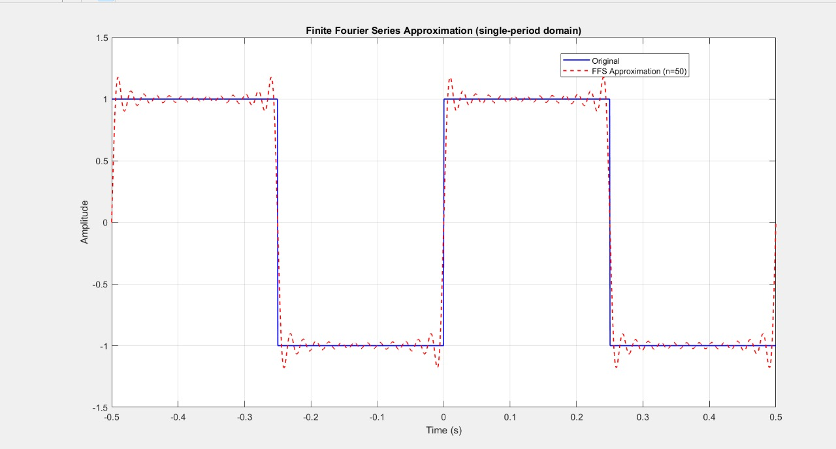

Figure 6. FFS approximation with T = 1s
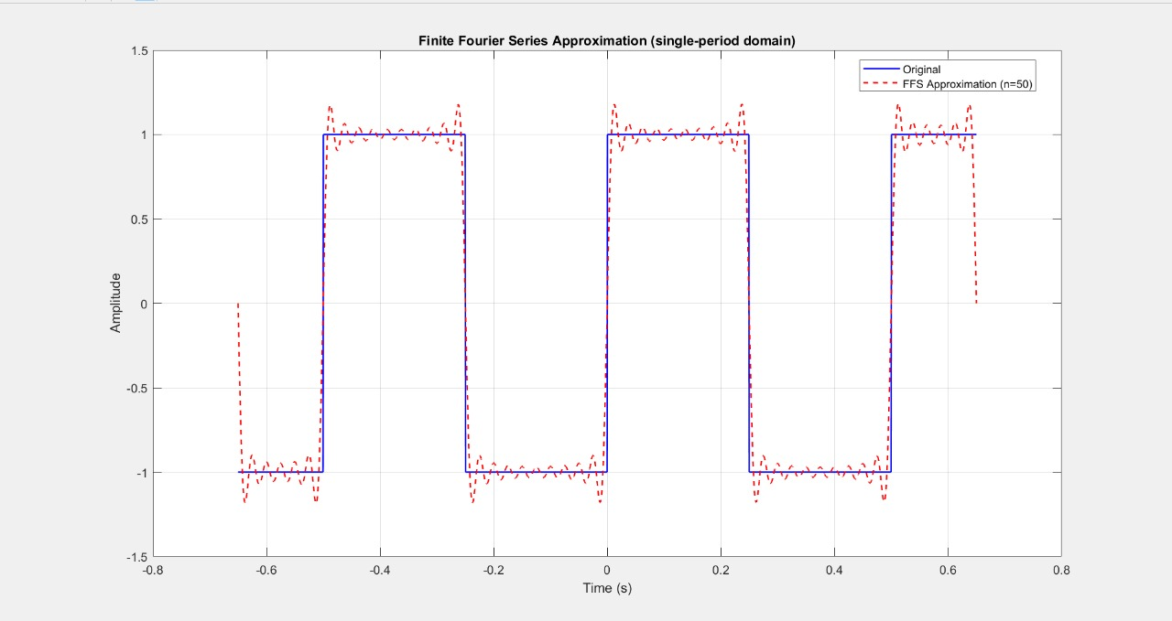

Figure 7. FFS approximation with T = 1.3s
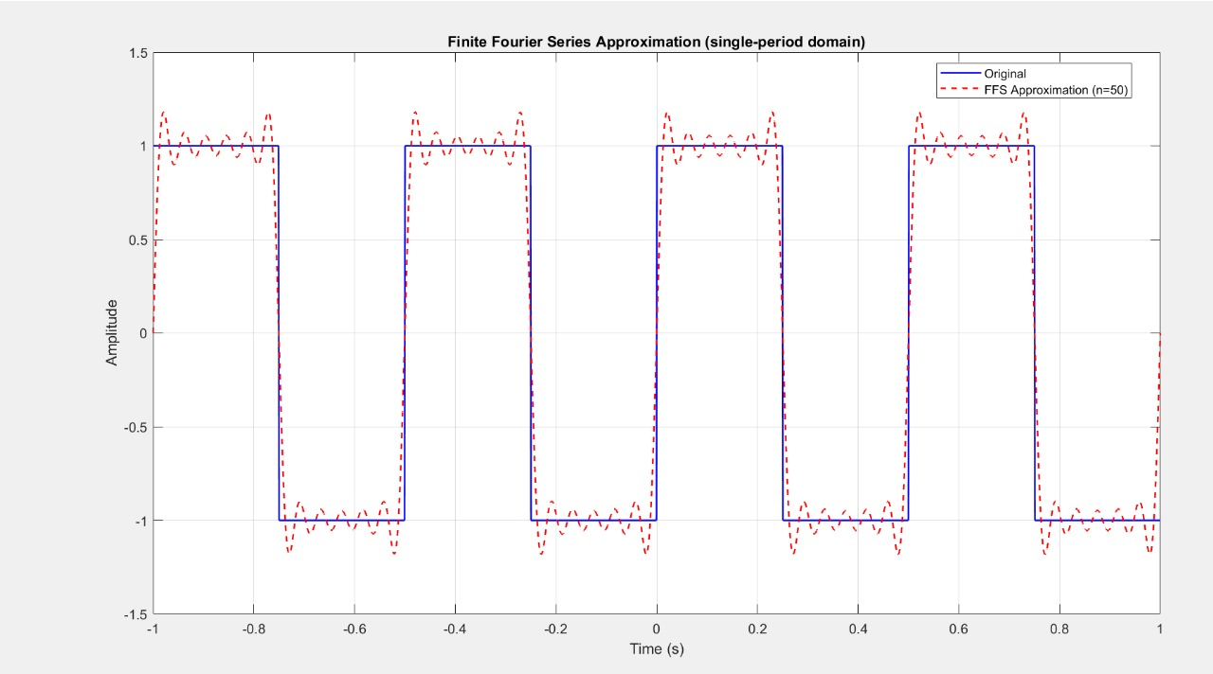

Figure 8. FFS approximation with T = 2s
Result: Keeping n fixed and varying T changes the periodic extension of the signal. A smaller T compresses the waveform and increases harmonic spacing in the frequency domain, leading to more distortion outside the main period.

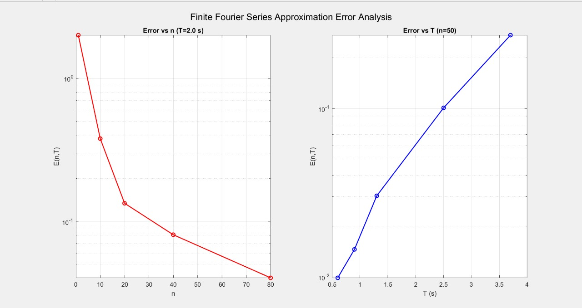
Error Analysis

Figure 9. Error analysis for the FFS
Result:
- The left plot illustrates how the MSE varies with the number of harmonics n, when the period is fixed. As n increases, the error decreases rapidly, highlighting the convergence of the truncated series toward the original signal.
- The right plot shows the dependance of the MSE on the signal period T for a fixed n. The true signal is a 2Hz square wave whose content is at odd harmonics. With fixed n, as T increases, f_{max} = n/T decreases, so fewer of those odd harmonics are captured, which leads to larger truncation. We notice that with T = 0.5s, f = 2Hz, which aligns perfectly with the true harmonics, causing the lowest error.

Discussion
As the number of terms n increases, the reconstructed signal converges more closely to the original waveform. Although small oscillations near discontinuities persist due to the Gibbs phenomenon. Additionally, varying the period T showed that longer periods require more harmonics for accurate reconstruction. The error analysis confirmed that increasing n reduces the mean-square error, while larger T values increase it, validating the expected convergence behavior of Fourier approximations.

Section 2 – Quantization
This section focuses on the process of quantization, which converts sampled continuous-amplitude signals into discrete levels for digital representation. The aim is to analyze how quantization resolution affects signal accuracy and distortion. The section begins with a simple two-level quantizer to illustrate coarse digitization, then extends to uniform multi-level quantization with increasing numbers of levels. Finally, near-optimal quantization using the Lloyd-Max algorithm is implemented to adapt level placement according to the signal’s probability distribution, minimizing distortion for a given bit rate.

2.1 – Two-Level Quantization
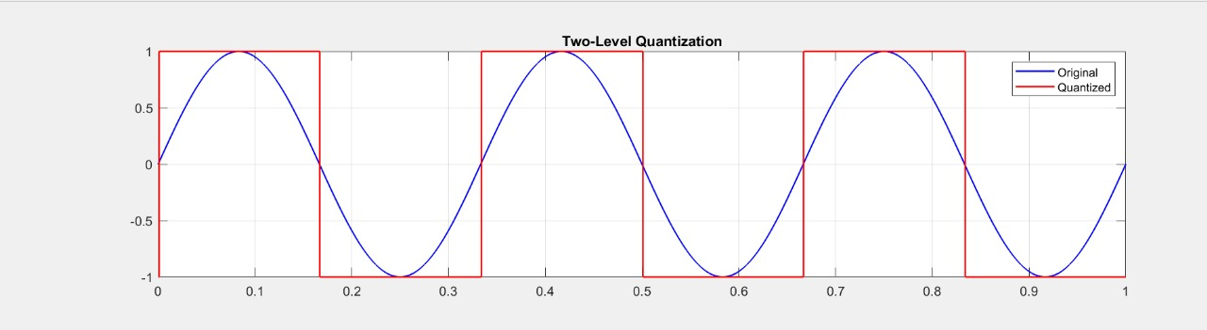

Figure 1. Two-level Quantization
This figure shows a cosine signal quantized into only two amplitude levels. The resulting waveform becomes a square-like signal where only the sign of the input is preserved. Fine variations of the original signal are lost, leading to severe distortion. This demonstrates the limitation of coarse quantization and motivates the need for more levels to improve fidelity.

2.2 – Uniform Multi-Level Quantization
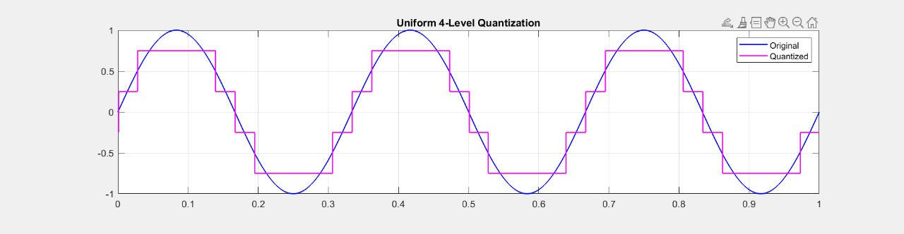

Figure 2. Uniform 4-Level Quantization
The quantized signal approximates the sinusoid with four discrete steps. Distortion is still clearly visible, especially near peaks and zero crossings.

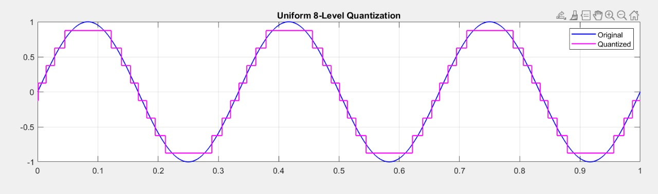

Figure 3. Uniform 8-Level Quantization
Increasing the number of levels provides finer resolution, and the quantized waveform more closely follows the analog curve.
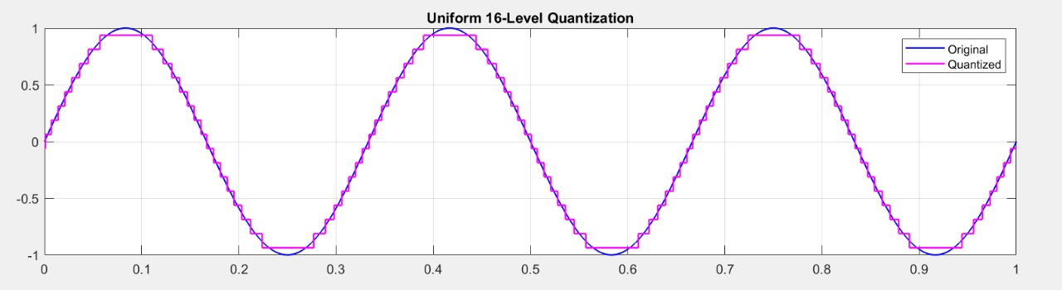

Figure 4. Uniform 16-Level Quantization
The signal is represented with high accuracy, and the staircase effect becomes barely noticeable.
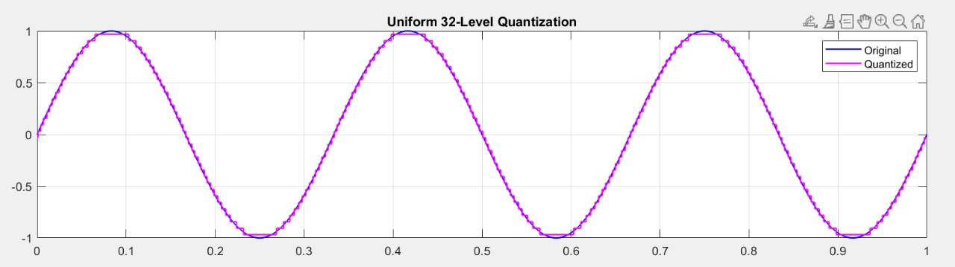

Figure 5. Uniform 32-Level Quantization
The quantized output almost completely overlaps with the original signal, indicating very low quantization noise.

Error Analysis 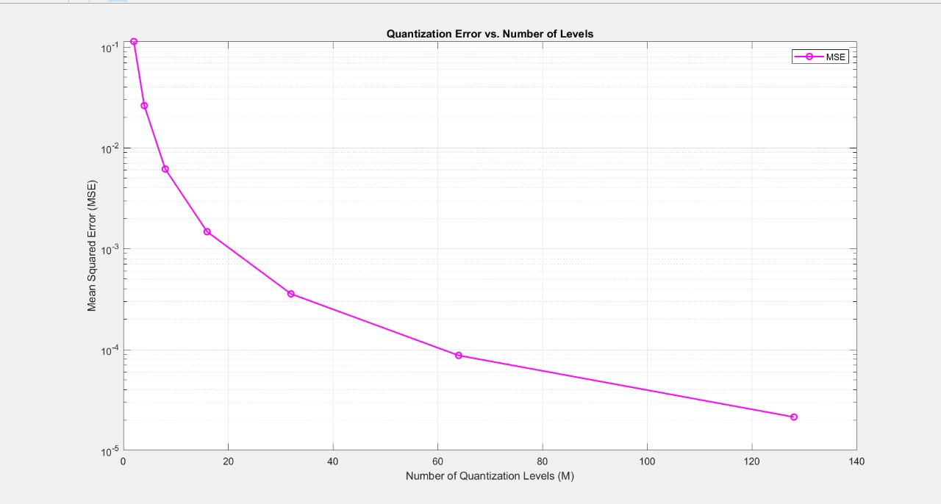
Figure 6. Quantization error vs Number of levels
This plot shows that the mean squared error (MSE) decreases rapidly as the number of quantization levels increases. The logarithmic decay demonstrates the inverse relationship between resolution and distortion, where doubling the number of levels roughly halves the error power. This trade-off highlights that higher fidelity requires more bits per sample.

2.2 – Near-Optimal Quantization (Lloyd-Max)

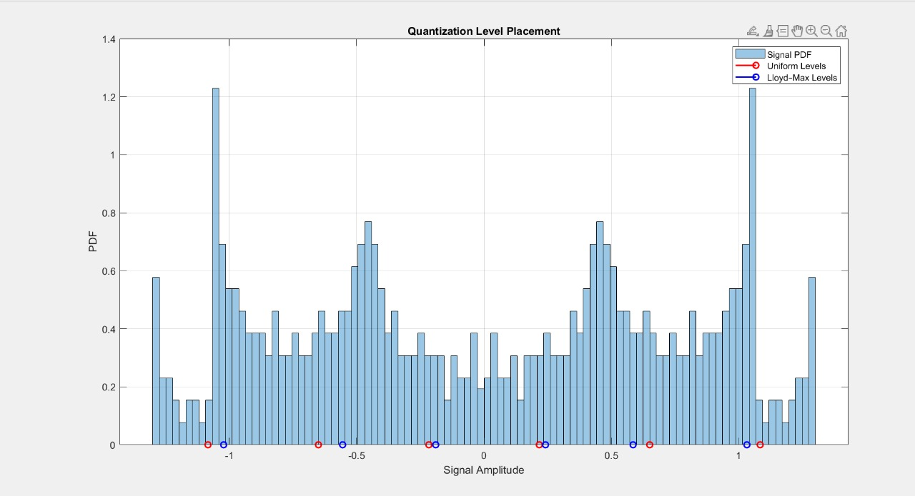

Figure 7. Quantization Level Placement M = 6

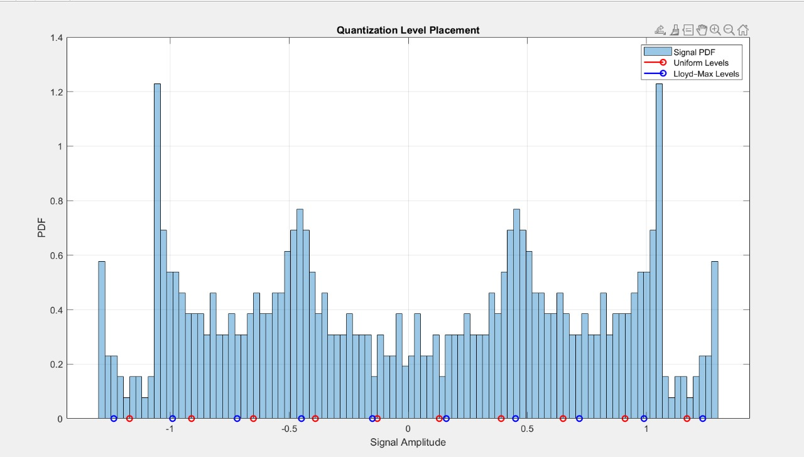

\

Figure 8. Quantization Level Placement M = 10

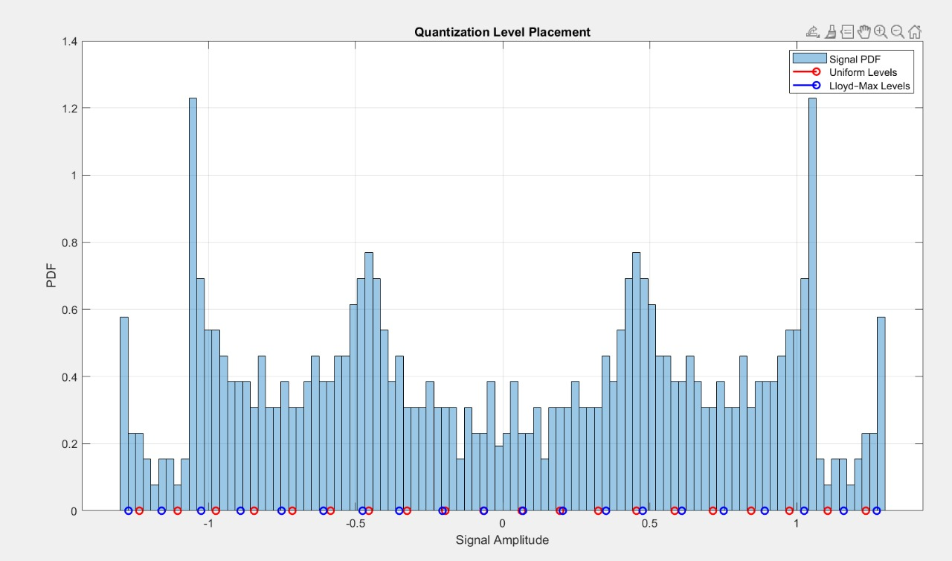

Section 3 – Source Coding and Decoding
3.1 – Baseline Huffman Coding
3.2 – (Bonus) Dictionary Coding via Lempel-Ziv

Figure 9. Quantization Level Placement M = 20
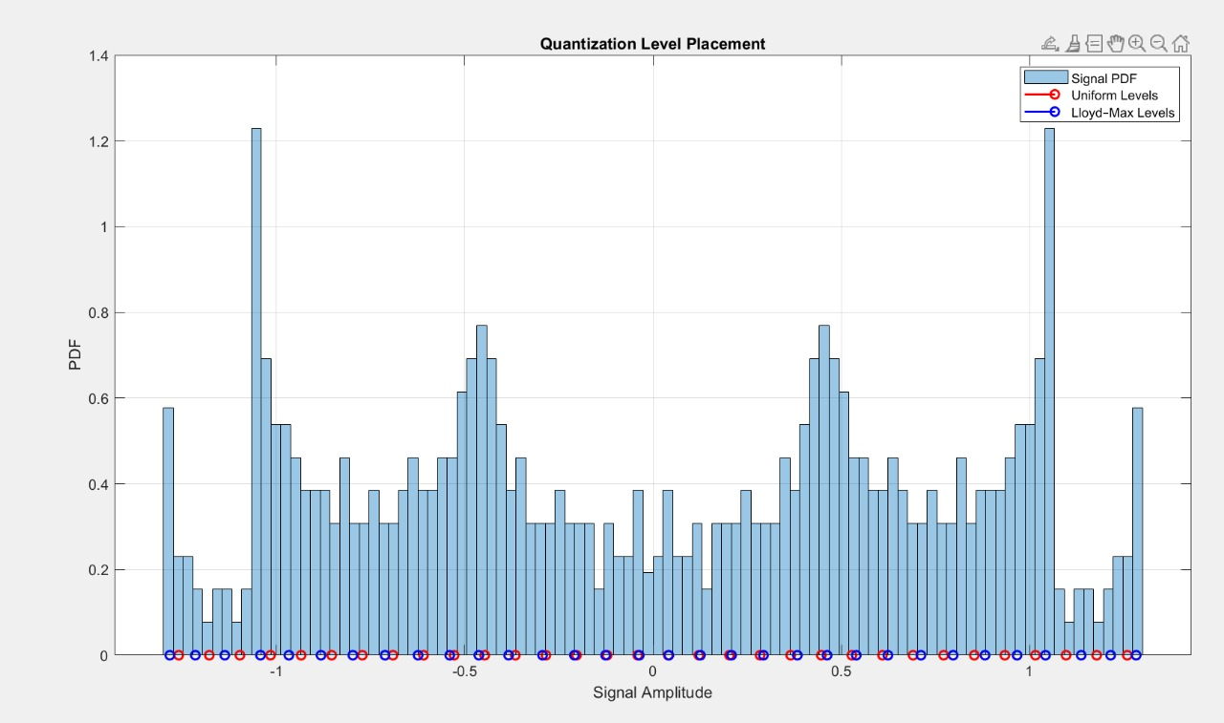

Figure 10. Quantization Level Placement M = 32
Result: These histograms show the probability density function (PDF) of the input signal along with the quantization levels for both uniform and Lloyd-Max quantizers. The Lloyd-Max levels (blue) are unevenly spaced, denser where the signal amplitude occurs more frequently. This adaptive allocation reduces overall distortion.

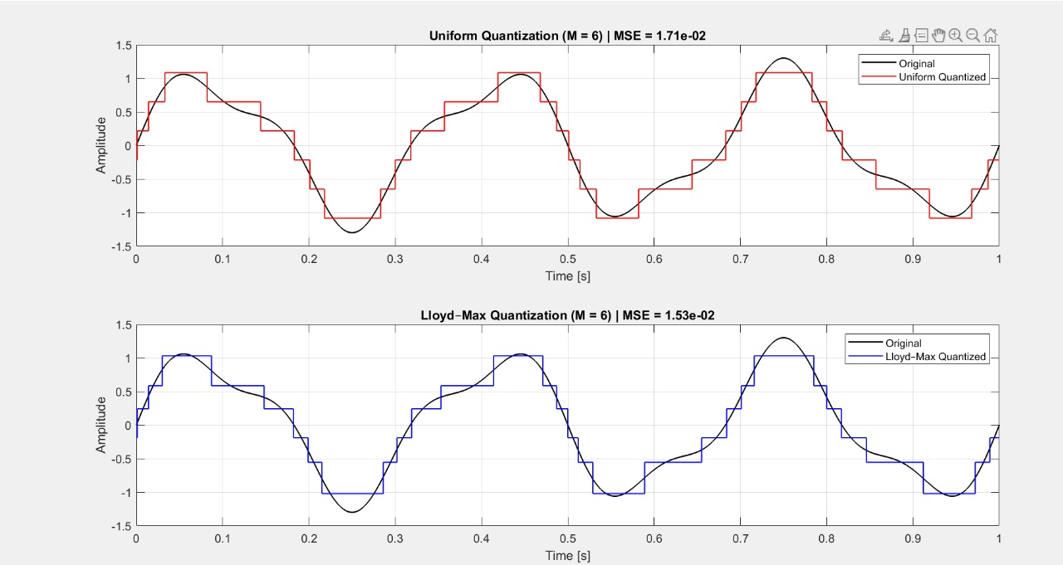
Comparisons

Figure 11. Comparison of Uniform and Lloyd-Max for M = 6
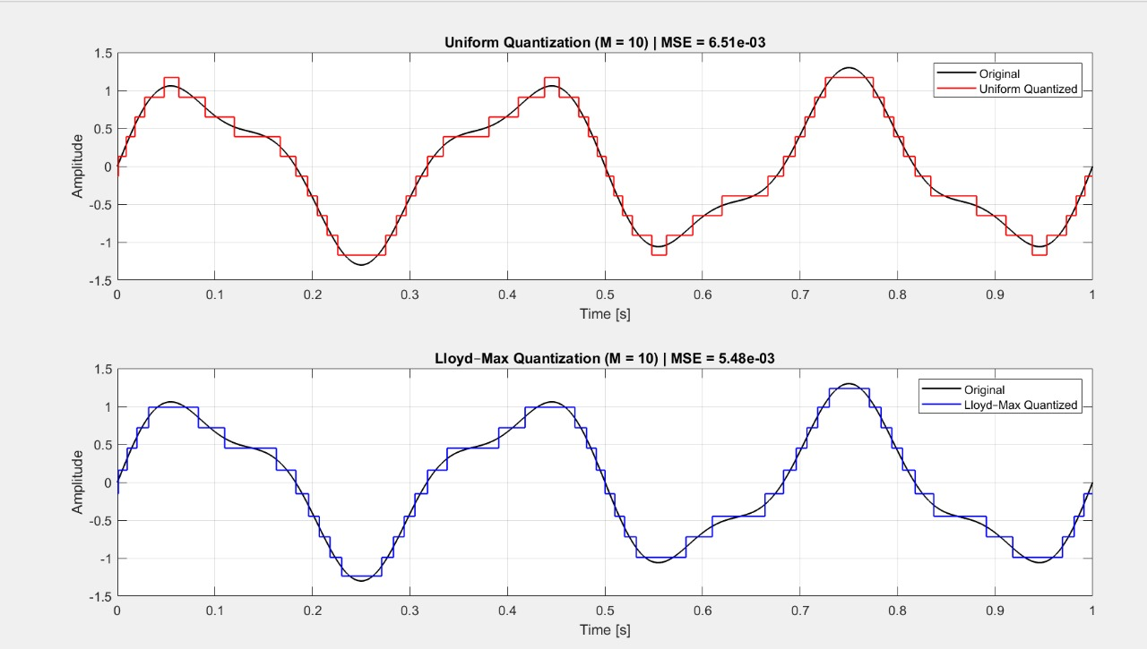

Figure 12. Comparison of Uniform and Lloyd-Max for M = 10
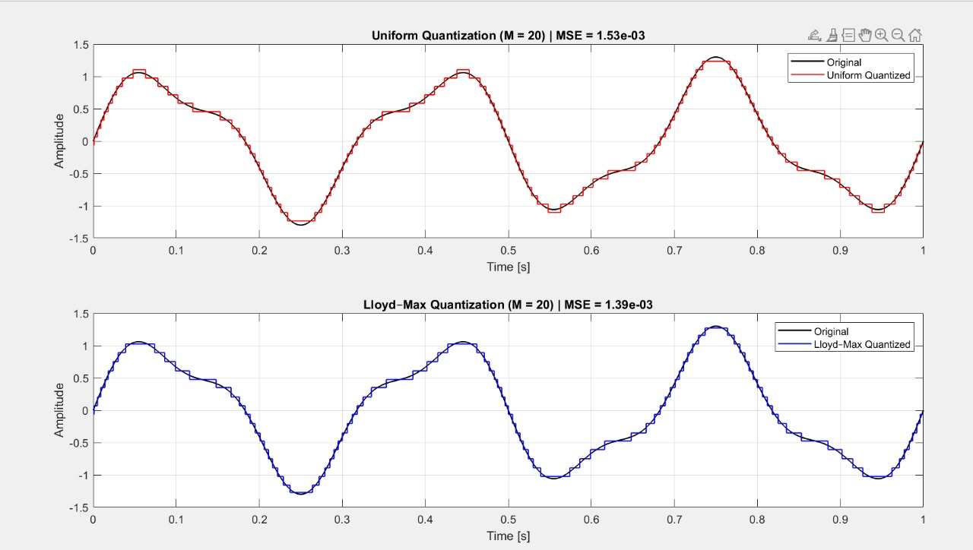

Figure 13. Comparison of Uniform and Lloyd-Max for M = 20
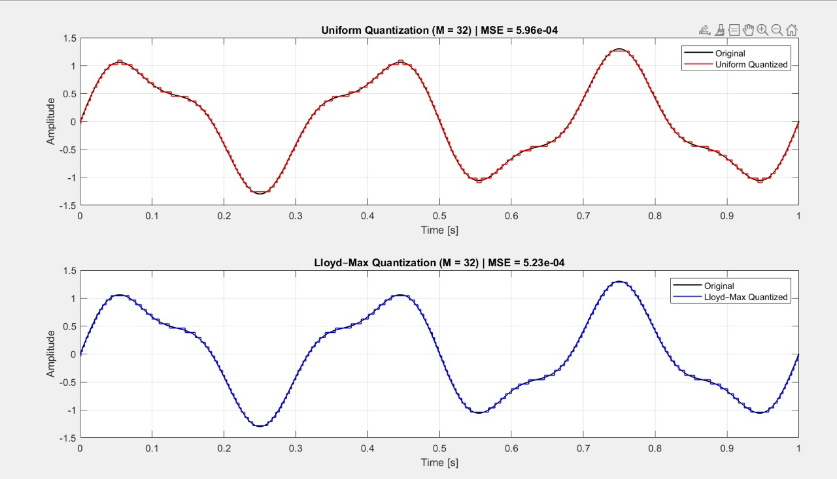

Figure 14. Comparison of Uniform and Lloyd-Max for M = 32
Result: Each pair of plots compares the uniform and Lloyd-Max quantized signals. For every case, the Lloyd-Max quantizer yields slightly lower MSE than the uniform one, confirming its efficiency. The improvement is most noticeable for low numbers of levels (e.g., M = 6 or 10) and becomes smaller as M increases since both quantizers converge toward the original signal.

Discussion
Uniform quantization performs well for signals with nearly uniform amplitude distribution, but becomes suboptimal when the signal’s probability density varies significantly. The Lloyd-Max quantizer achieves better performance by adapting level spacing to the signal statistics, thus minimizing MSE. The observed results confirm that higher quantization rates and adaptive level placement both enhance signal reconstruction quality, balancing bit rate and distortion effectively.

Section 3 – Source Coding and Decoding
This section explores lossless source coding, which compresses data without losing any information. The focus is on Huffman coding, a variable-length encoding technique that assigns shorter codewords to more frequent symbols, reducing the average number of bits per symbol compared to fixed-length coding. The efficiency of Huffman coding is evaluated across different input types — from simple discrete sequences to signals quantized with uniform and Lloyd-Max quantizers. The section concludes with a comparison against dictionary-based coding using the Lempel–Ziv algorithm, which achieves compression by exploiting repeated patterns rather than symbol probabilities.

3.1 – Baseline Huffman Coding

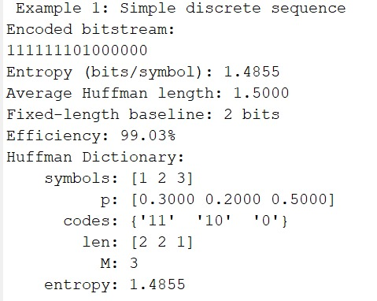

Figure 1. Simple Discrete Sequence
This example demonstrates Huffman coding on a simple 3-symbol discrete source.
The Huffman dictionary assigns the shortest codes to the most probable symbols, achieving an average code length of 1.5 bits/symbol versus a fixed 2 bits/symbol baseline, resulting in 99.03% efficiency.
This confirms the principle that Huffman coding closely approaches the theoretical entropy limit (1.4855 bits/symbol) for small symbol sets.
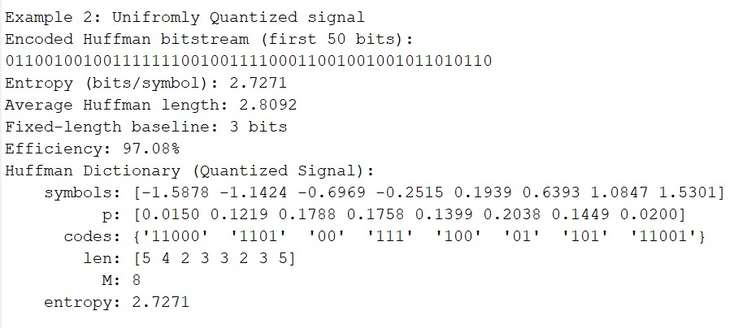

Figure 2. Uniformly Quantized Signal
Here, Huffman coding is applied to a uniformly quantized signal with M = 8 levels.
The computed entropy is 2.7271 bits/symbol, and the average Huffman length is 2.8092 bits/symbol, giving an efficiency of 97.08%.
The Huffman dictionary shows that lower-probability amplitude levels are assigned longer bit sequences.
This illustrates how Huffman coding efficiently adapts to symbol probabilities, even for analog-derived data.

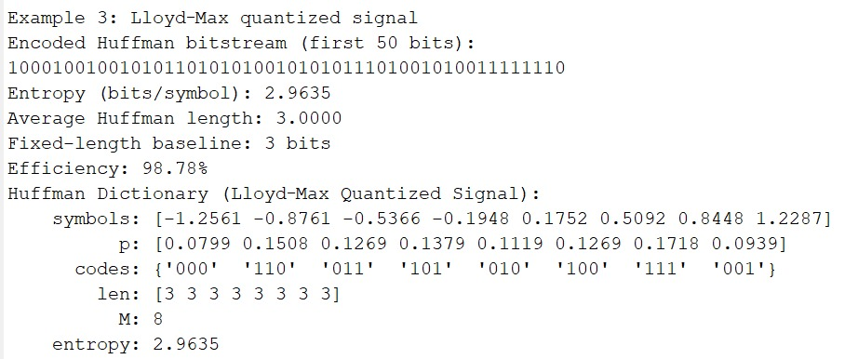
Figure 3. Lloyd-Max Quantized Signal
In this case, the same signal is quantized using Lloyd–Max optimization before Huffman encoding.
Due to better alignment of quantization levels with the signal’s probability density, the symbol distribution becomes more balanced, slightly increasing the entropy (2.9635 bits/symbol) but improving coding accuracy.
The efficiency reaches 98.78%, and the average length (3.000 bits/symbol) nearly equals the fixed baseline, showing that most gain had already been achieved during quantization optimization.
Results
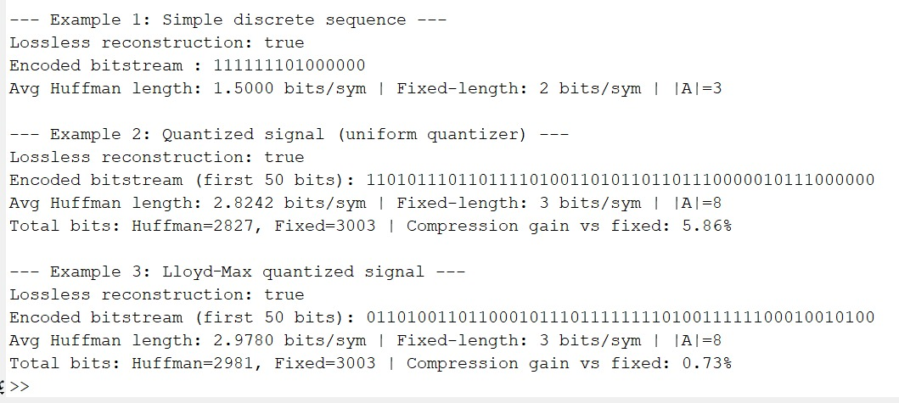
Figure 4. Summary of Huffman Coding Results
This summary compares the three cases — simple discrete, uniform quantized, and Lloyd–Max quantized signals — highlighting their respective entropies, average code lengths, and achieved compression ratios.
For all examples, the reconstruction is lossless, with Huffman code lengths approaching the theoretical lower bound given by entropy.
Compression gain versus fixed-length coding was ~6% for the uniform quantizer and ~1% for the Lloyd–Max quantizer, indicating that optimized quantization leaves less redundancy for the coder to exploit.

Block Huffman Coding
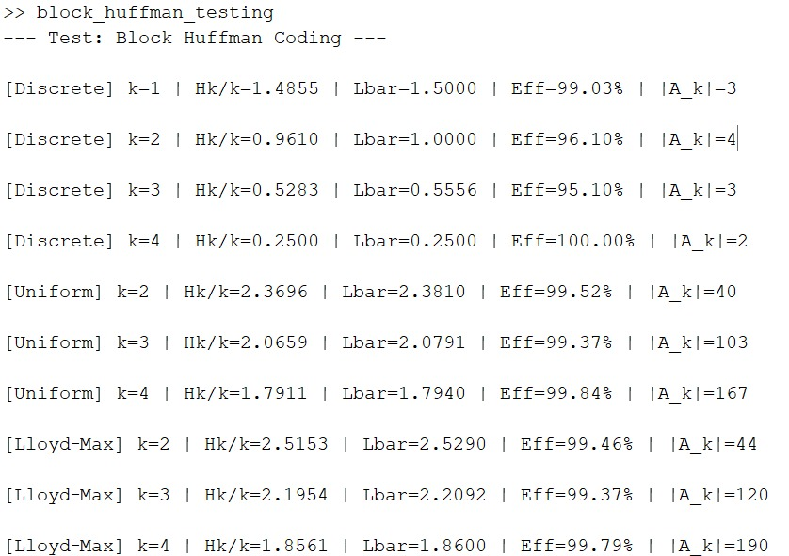
Figure 5. Block Huffman Coding
This figure presents the results of block Huffman coding, where symbols are grouped in blocks of size k = 1–4.
As k increases, coding efficiency approaches 100% for all cases (discrete, uniform, and Lloyd–Max).
For instance, the discrete case reaches 100% efficiency at k = 4, and both quantized cases exceed 99.5% efficiency for k ≥ 2.
However, this improvement comes with rapidly increasing codebook size (|Aₖ|), reflecting the trade-off between compression performance and computational complexity.

Uncoded Channel Simulation 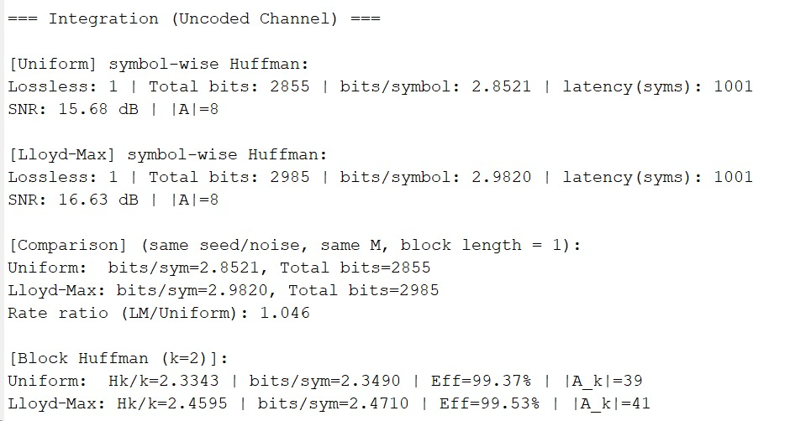
Figure 6. Uncoded Channel Simulation Integration
This part integrates the Huffman coding system into a simulated uncoded channel to evaluate practical bit usage and SNR performance.
Both uniform and Lloyd–Max quantized signals are encoded using symbol-wise and block Huffman methods.
Results show:
- Uniform Huffman: 2.8521 bits/symbol, SNR = 15.68 dB
- Lloyd–Max Huffman: 2.9820 bits/symbol, SNR = 16.63 dB
The Lloyd–Max version achieves slightly better signal quality at the expense of a marginally higher bit rate (rate ratio ≈ 1.046).
For block size k = 2, efficiency again exceeds 99%, demonstrating consistent near-entropy performance across quantization types

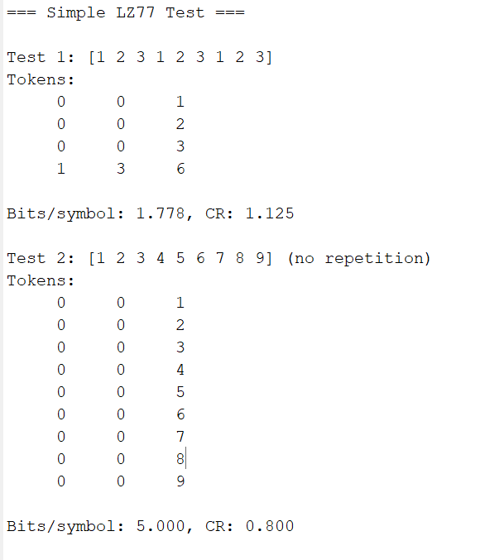
Section 4 – Bonus — Dictionary Coding via Lempel–Ziv

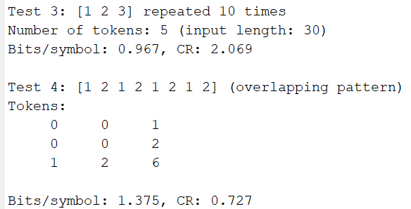

LZ77 Performance
LZ77 was first tested independently on synthetic discrete sequences to verify correct operation. The method correctly compressed sequences that contained clear repetition. For example, the sequence [1 2 3] repeated ten times was reduced to five tokens with an achieved 0.967 bits per symbol and a compression ratio of 2.069. Sequences with no structure, such as [1 2 3 4 5 6 7 8 9], produced only literal tokens with 5 bits per symbol and a compression ratio below 1. These tests show that the implementation works as expected: LZ77 provides compression only when the data contains repeated segments that appear inside the sliding window.
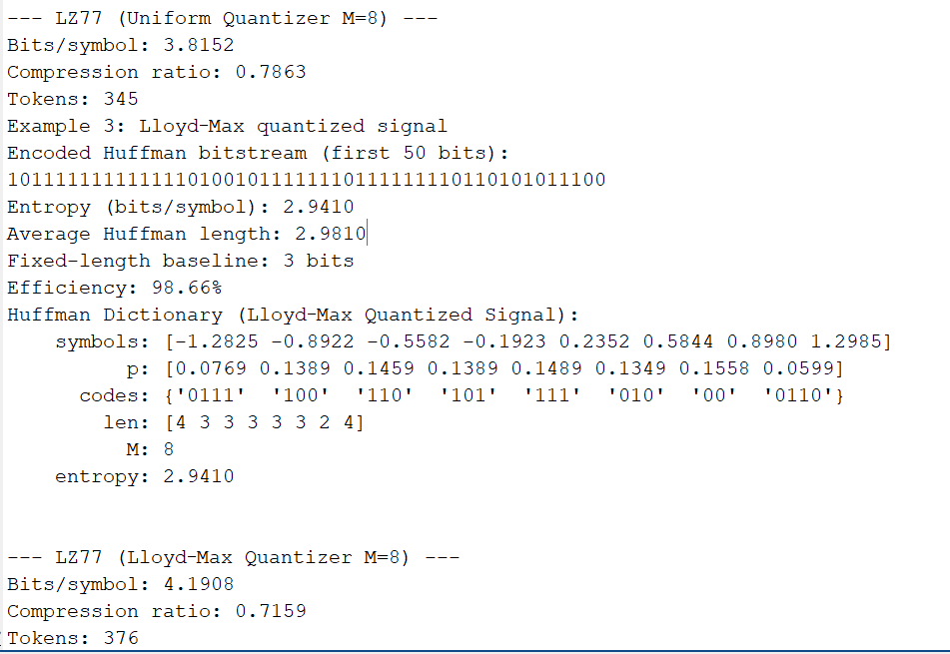
LZ77 applied to quantized signals

The same LZ77 encoder was then applied to the symbol streams produced by the uniform and Lloyd–Max quantizers. Both streams are driven by a noisy sinusoid, which produces symbols that fluctuate nearly independently from one sample to the next. As a result, long repeated segments rarely occur. Because LZ77 relies on the repetition of contiguous patterns to form match tokens, the lack of temporal redundancy forces the encoder to output mostly literals. This leads to an expansion rather than compression.
For the uniform 8-level quantizer, LZ77 produced 3.8152 bits per symbol and a compression ratio of 0.7863. For the Lloyd–Max 8-level quantizer, the result was 4.1908 bits per symbol with a compression ratio of 0.7159. In both cases, the compressed size exceeded the raw fixed-length representation (3 bits per symbol). This confirms that the quantized signals behave almost like memoryless sources from the point of view of LZ77.
Comparison with Huffman coding
Huffman coding depends on the probability distribution of individual symbols and does not require temporal structure. For both quantizers, the entropy and symbol frequencies created some skew, allowing Huffman to reduce the average length slightly below the 3-bit fixed baseline. In contrast, LZ77 cannot make use of symbol skew, and since the sequences contain little repetition, its performance is significantly worse.
Overall, for sources with minimal repetition and noise-driven variations, entropy-based compressors such as Huffman are more suitable than dictionary-based methods like LZ77.
Summary table
The results for the two quantizers are summarized below.
Quantizer comparison (M = 8 levels):
Method | Uniform Quantizer | Lloyd–Max Quantizer
Entropy H(A) | 2.7582 bits/sym | 2.9410 bits/sym
Huffman (symbol) | 2.8212 bits/sym | 2.9810 bits/sym
Fixed-length | 3 bits/sym | 3 bits/sym
LZ77 bits/symbol | 3.8152 bits/sym | 4.1908 bits/sym
LZ77 compression ratio | 0.7863 | 0.7159
LZ77 number of tokens | 345 | 376
These results show that for this type of quantized signal, Huffman coding remains close to the theoretical entropy, while LZ77 performs poorly due to the absence of repeated structures.

